Data validation tools are useful in Excel workbooks for standardizing data entries. Clean, standardized data helps keep track of, for example, how many appointments an advisor had within a range of dates. Some copies of the Tracker’s data validation has been reported to cause hard error messages to pop-up. This is an unintended consequence of dealing with the large data fields in the Tracker, but thankfully the issue needs only a quick and easy fix.
Step 1: Identify the columns with data validation. Typically, these would be all of the date-related columns in which the advisor is supposed to input dates. In my tracker, these are columns M, P, Q, R, S, T, U, & V.

Step 2: Highlight each column with data validation. You can highlight the entire set by holding “Ctrl” while clicking on the letter atop each column.

Step 3: Click on the “DATA” tab in the toolbar ribbon. See the following picture:
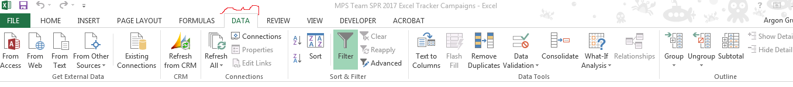

Step 4: Click on the check-symbol in “Data Validation”. See the following picture:
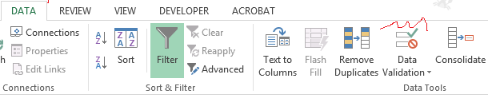

Step 5: If the following pop-up appears, click “OK”. If not, continue to Step 6.
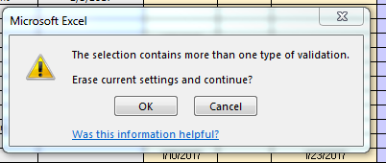

Step 6: Click on “Clear All”, and then “OK”. You have cleared the Data Validation settings on your tracker, and the error should not occur again. Be sure to save the document! See the following picture:
