Withdrawing (removing from all courses) BEFORE the Fall/Spring Term begins
Note: Summer withdrawal is NOT changing
The WS code will no longer be used to remove all courses BEFORE the first day of the Fall or Spring term. In order to process a withdrawal BEFORE the first day of the Fall or Spring term, use the DC status code in the “Course Information” block. The “Enrollment Information” block status remains EL.
Example:
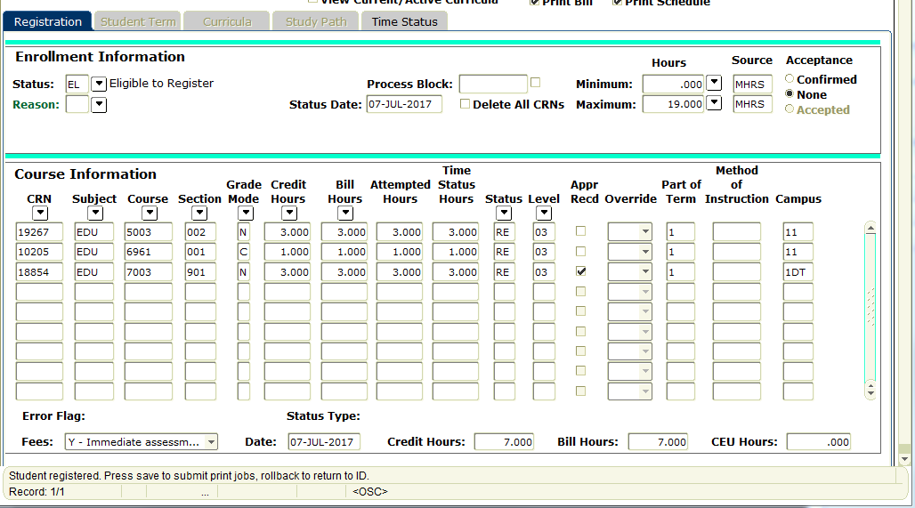
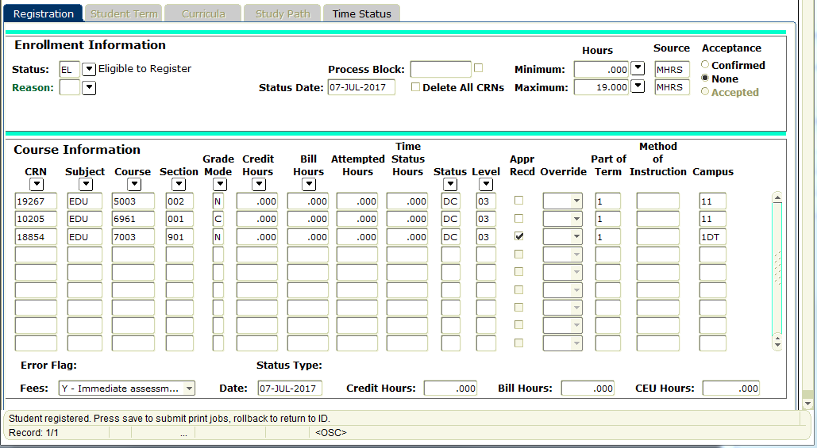
Only change the status code to DC here

Verify a 100% refund in SFAREGF
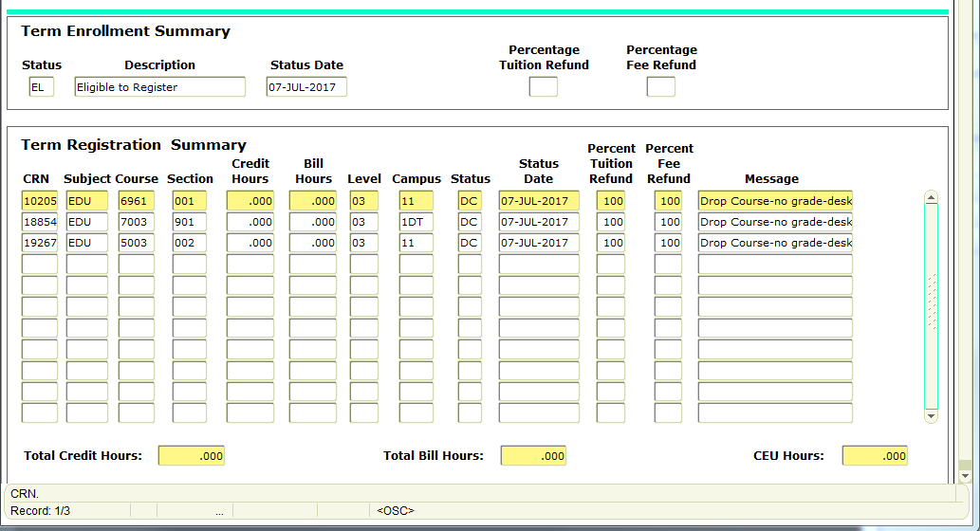

AFTER the Fall/Spring term begins, use the WS status code in the “Enrollment Information” block
