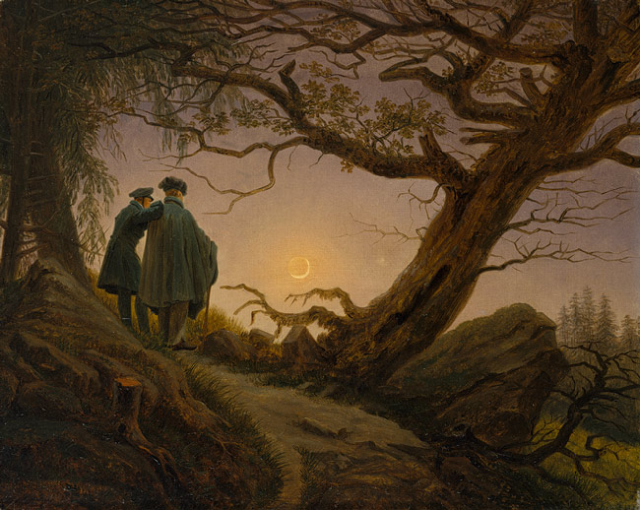

Mysteries and Mind
German Short Stories from the Romantic Era to the Late 20th Century

Spring Semester 2016, TR 2:30-3:45
GER 4003 Topics in German Literature
CSH 3023 Studies in Comparative Literature

This course examines short stories and novellas from the German literary tradition. Authors covered include Hebel, Kleist, Hoffmann, Droste-Hülshoff, Schnitzler, Th. Mann, Kafka, Brecht, Kaschnitz, Lenz, Bachmann and Bobrowski. Tales often include elements of psychological inquiry and mystery. Students will become acquainted with the work of important German writers and will develop skills for interpreting, speaking and writing about this literary genre. Students registering under CSH 3023 read and write about the works in English. Students registering under GER 4003 read and write about the works in German.

Instructor: Dr. Christopher Wickham, christopher.wickham@utsa.edu ; (210) 458 7340. Office: MH 4.02.10

