Adding an Attribute in SGASADD
- Go to SGASADD in Banner
- Enter the student ID number and the current term
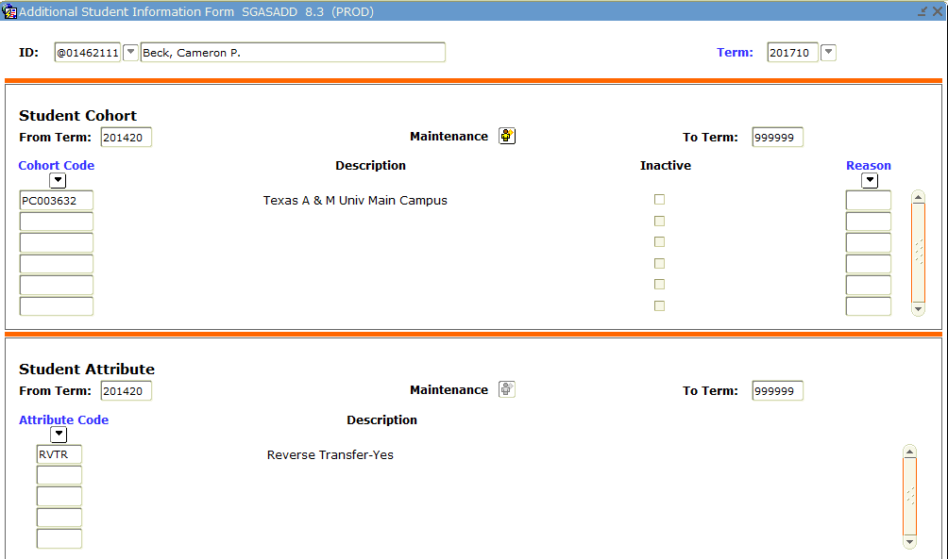

Note: If the student’s first semester is in the future, enter that term.
3. Hit the Next Block button (or Ctrl+Page Down) twice
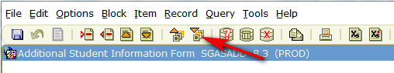
4. Select Record then Duplicate
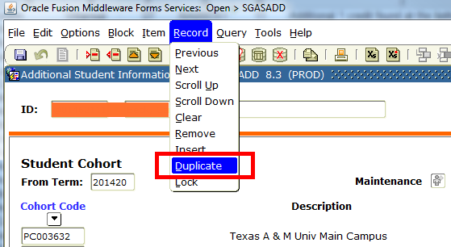
5. Hit OK in the pop up window
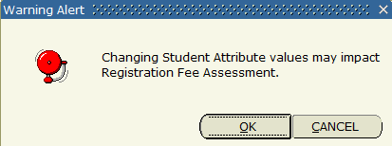
6. Enter the attribute in one of the blank fields.
- Enter in AISW if you want a UTSA course to satisfy the AIS requirement.
- Enter 030W if you want CHE 1073 or CHE 1103 to count as core science.
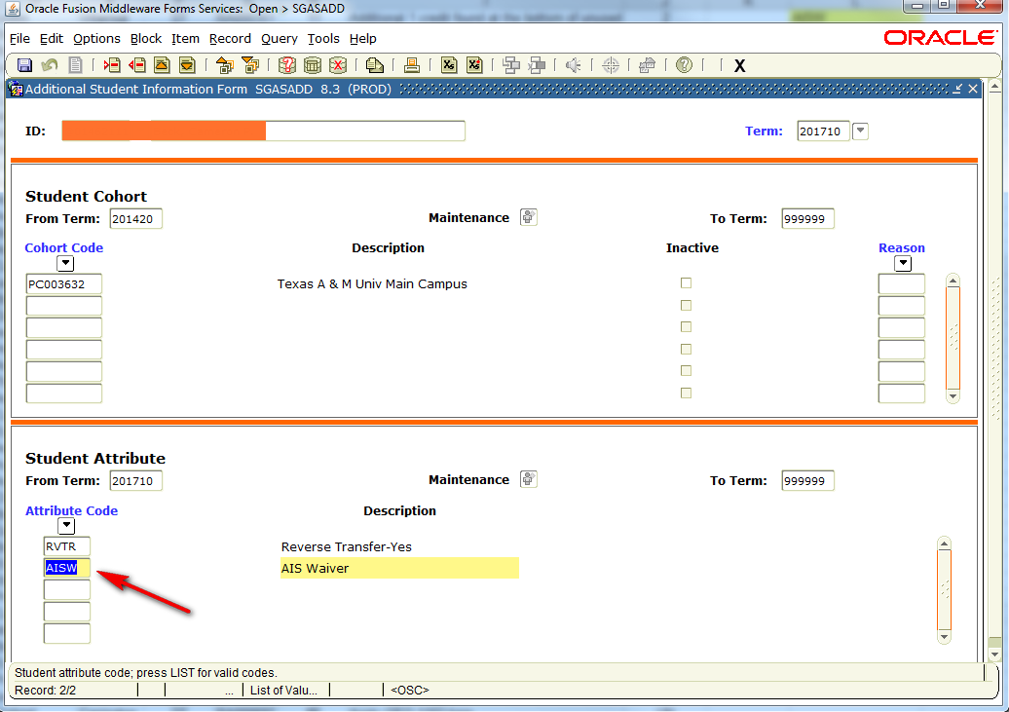
8. Hit the Save button (or F10).
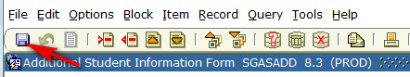
7. Review DegreeWorks to be sure that the appropriate requirement is now satisfied.
Notes:
- If a different core science course was approved via petition to sub for core science other than one of the CHE courses mentioned above, please send the student’s ID number, name and situation to DegreeWorks@utsa.edu.

