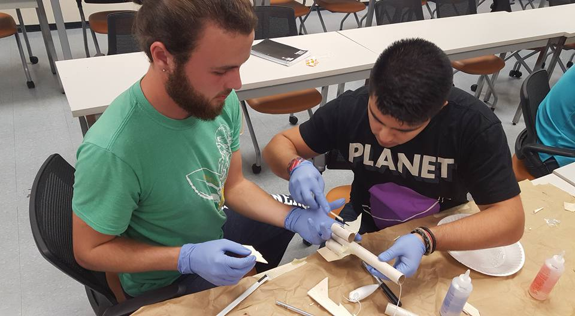  Goals for Our Members  - To provide exposure to rocketry and aerospace engineering  - Develop an understanding of rocket design (propulsion systems, controls, structures, flight trajectory, etc.)  - Promote and develop a professional engineering problem-solving approach.  - Help members develop leadership and ‘real world’ analytical problem solving skills.  - Encourage the development and selection of STEM careers in future members/students.  - Help students apply ideas learned in the classroom and apply them in a real setting.  - Develop/test/prototype new technologies or projects to further the development of students work and school-based projects.
  Who We Are
  About Us
  Built from curiosity and pure determination, the Aeronautics and Rocket Club, also known as ARC, is UTSA’s first student organization dedicated to the design, research and testing of rocket propulsion systems and flight vehicles. Founded in late June 2016, ARC sought to fill an urgent need for an applied aerospace engineering program at UTSA as well as to elevate UTSA’s prestige as it seeks for Tier One status. All members, no matter what degree, age or background, are provided with limitless resources and endless opportunities to learn and advanced their knowledge in rocket systems while at the same develop a professional work etiquette. Although ARC is a student organization, it seeks to not only become an inspiration to the university, but also to the San Antonio area and South Texas region. We aim to ignite a desire and passion to reach for the cosmos and explore the Final Frontier through innovation, interaction, and the thrust of a committed group.
  Contact Us
  Phone: (210) 391-5292
  Email: arcutsa@gmail.com
  Web: [Web address]
  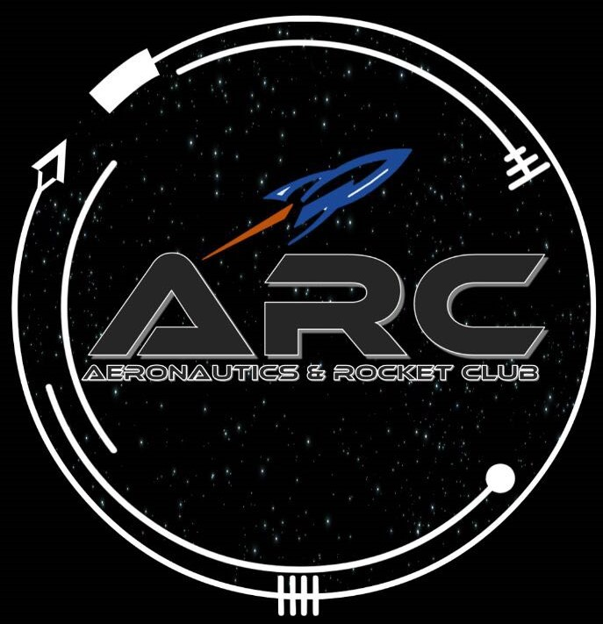 |  | Aeronautics and rocket club  One UTSA Circle  San Antonio, TX 78249
  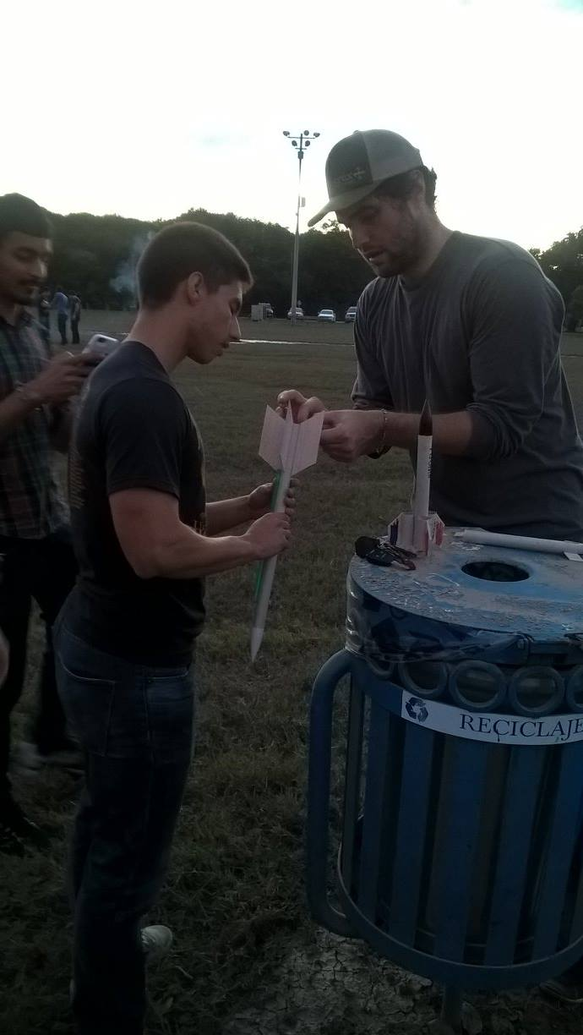
  Aeronautics and rocket club
    - Flying For Your Future

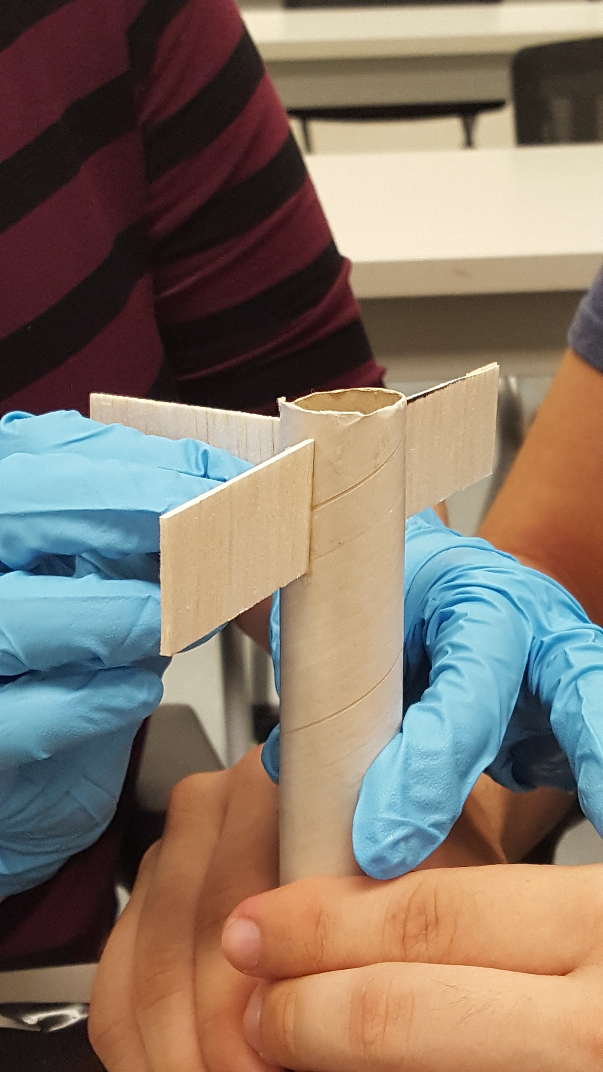  Present and Prospective Operations  Phoenix I (present) – To design, fabricate and launch a set of rockets designed to reach an altitude of at least 1000 feet.  Phoenix II (prospective) – Fabricate and launch a family of rockets set to reach >3000 feet.  Phoenix Heavy (prospective) – ARC will design, fabricate, test, and launch a rocket capable of reaching of carrying a 1 lb payload to an altitude of over 1 mile. The design will be kept and repeated for future launches and payloads. |  |  | “We are ready for the dawn of a new era…” – Elon Musk  Administration & Architecture of ARC  Erick Castillon – President/Lead Advisor  Dr. James Johnson – Academic Advisor  Ivan Gomez - Vice President  James McGeehee - Treasurer  Ramon Vazquez – Secretary  Ashley Rymer – Administrative Assistant  Prinzton Flores – Project Advisor  Dylan Pyka – Project Advisor  Daniel Mancera – Project Advisor  How do we operate?  At ARC, we operate unlike no other student organization. All projects are divided into divisions: engineering, outreach, finances, and media. Simulating the real world after university is critical for the advancement of our engineers and members as they can experience the stresses but rewards of a successful mission while at the same time learn how an actual company operates in a simulated environment. |  |  | Associated Partners  Advanced Robotics (AR)  UTSA Department of Astronomy  ARC Sponsors  Southwest Research Institute  UTSA Department of Astronomy  Contact Us  Erick Castillon  Erickc.arc@gmail.com  (210) 391-5292  One UTSA Circle  San Antonio, TX 78249

