Mexican American Studies
Courses Fall 2016

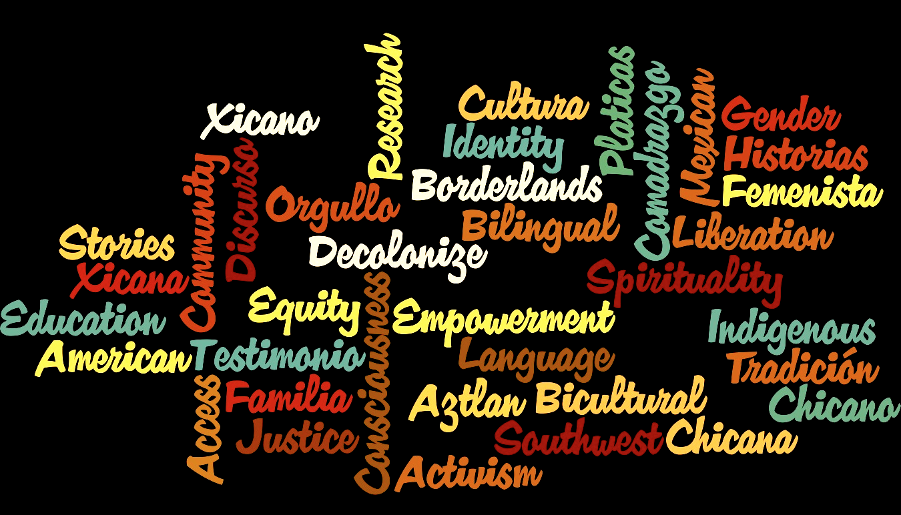

Intro to Chicano(a) Studies
TR 12:00-1:15pm Downtown

Mexican Americans in the SW
TR 1:30-2:45pm Downtown

