How did Americans go from this . . . to this?

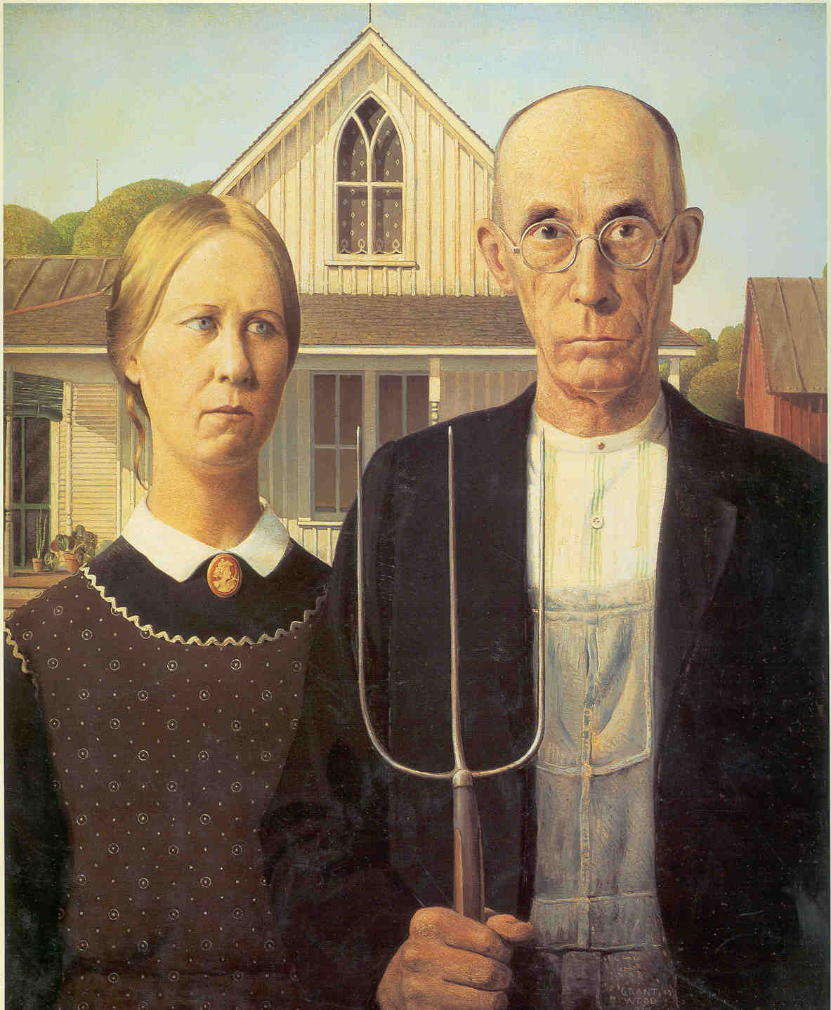

Find Out this Summer!!
Take HIS 3433: Emergence of Modern America
with Dr. Elaine Turney

Second 5-week Summer Session July 5, 2019 to August 10, 2019. M-F at 2:30.

Examine the unprecedented wealth accumulated by a handful of men juxtaposed against the unprecedented poverty experienced by the “New Immigrant”, the plight of organized labor, the closing of the West, the new alignment of the major political parties, the magnitude of cultural hubris in the post-Civil War United States, and so much more! Learn how America emerged from the divisiveness of Civil War and rose to a leading nation in the modern world.

