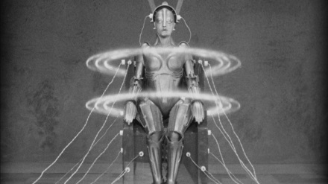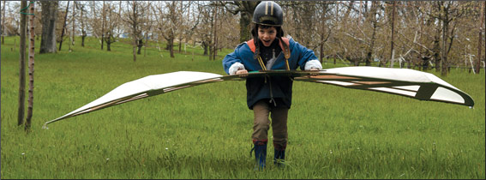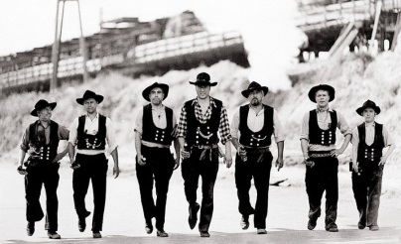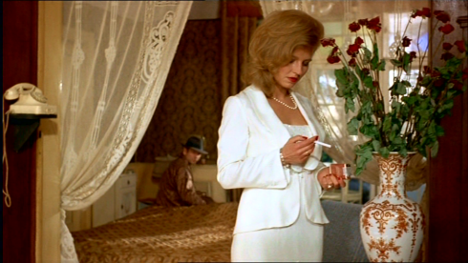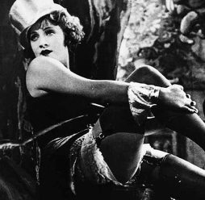
german cinema-100 years | Fall Semester 2016  TR 1:00-2:15  GER 4213 Topics in German Culture  MES 3113 Topics in Film Studies  Using masterpieces of German-language cinema from the 1920s to the 2000s, this course looks at the history of the medium in Weimar Germany, the Third Reich, East Germany, West Germany, post-unification Germany, Austria, and Switzerland.  No knowledge of German required.  All films viewed with English subtitles. | - Fritz Lang, Metropolis  - Josef von Sternberg, The Blue Angel  - Leni Riefenstahl, Olympia  - Wolfgang Staudte, The Murderers are among Us  - Frank Beyer, Trace of the Stones  - Margarethe von Trotta, Marianne and Juliane  - Rainer Werner Fassbinder, The Marriage of Maria Braun  - Michael Verhoeven, The Nasty Girl  - Axel Corti, Welcome in Vienna  - Wolfgang Becker, Goodbye, Lenin  - Oliver Hirschbiegel, Downfall  - Fredi Murer, Vitus  Instructor: Dr. Christopher J. Wickham  christopher.wickham@utsa.edu  MH 4.02.10. (210) 458 7340
