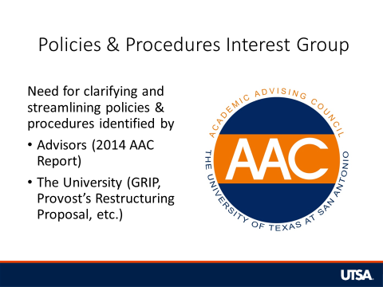
The Policies & Procedures Interest Group has been discussing a lot of different things, but we decided to start with a few that the Associate Deans will have to approve. We’ve come up with some general recommendations but want to get feedback and make sure that we’re mostly in agreement before taking them to the Associate Deans.

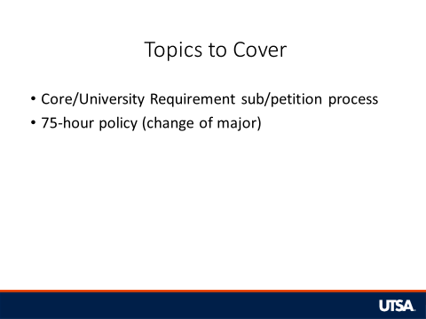
The first two that we decided to focus on are the process for submitting core/university requirement petitions and the 75-hour major change policy.
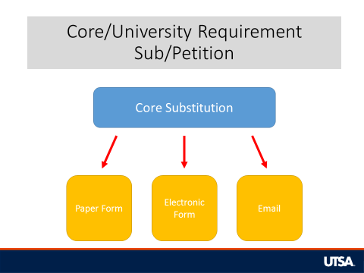
Currently there are multiple processes for submitting Core/University Requirement Substitutions/Petitions. Some are sent in paper form by intercampus mail, some with electronic forms, and others with a simple email.
We also found that we weren’t always sending them to the same places. For instance, a core substitution for the Social & Behavioral Sciences requirement was being sent to Dr. Levitt in COLFA by some and to Dr. Wyatt in University College by others. Apparently there were times when they were both approving them too which doesn’t help. Even when we were sending them to the same place though, we weren’t all sending them in the same way. Some sent it electronically while others sent the paper form.

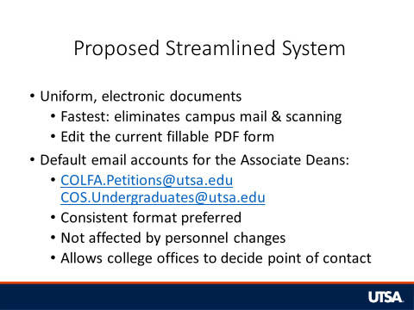
We are proposing that there be a uniform, streamlined system in order to improve efficiency and eliminate confusion about where petitions are sent, who they are sent to, and how they are sent. We would prefer the following features to be a part of the system:
- A uniform set of electronic documents should be used.
  - An electronic form is the fastest because it eliminates the processing time of intercampus mail. This is especially true in the case of the Downtown Advising Center.
  - Also, advising centers always end up scanning or saving electronic documents anyway. This would allow us to skip the step of scanning.
  - The current fillable PDF form is basically what we want to use, but we want to take out some things that are no longer necessary (address, expected grad date, etc.). This will save us a little time filling them out.
- We also want all of the Associate Deans to have generic, college-specific email accounts. Some already have them and others are discussing the possibility of getting them.
  - Currently, they have different formats, but ideally each college’s email account would be formatted the same. If they can’t agree to a consistent format, we will create a directory for everyone to reference.
  - This would essentially eliminate the need for advisors to know the varied preferences of each college.
  - It would also ensure that changes in staffing in the Deans’ offices do not change the process.
  - Also, each Dean’s office would still be able to determine whether the Assoc. Dean or someone else, like an admin, would check the account.
    - Multiple people could even be given access to the account.

Agree or disagree? Any comments/concerns?

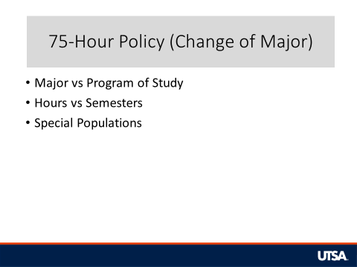
When it comes to the 75-hour policy, there were three areas that we thought needed to be addressed.
- The first is whether the policy applies just to majors or to any changes to the student’s program of study.
- The second is whether credit hours needed or semesters remaining until graduation should be the deciding factor in these decisions.
- The third is how to apply the policy to several special populations.
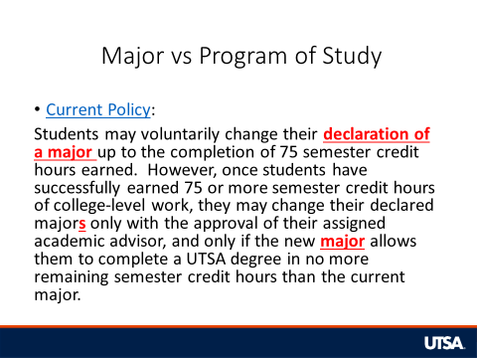
The first thing we plan to ask the Associate Deans is “What is the intended purpose of this policy?”
We were under the impression that it was to prevent students from delaying graduation by making changes. The current policy only mentions changes to their major though, and we know that students can make several changes that would delay graduation.

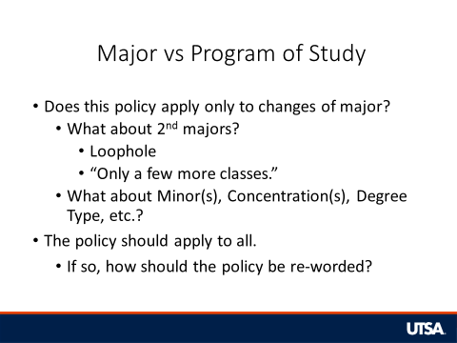
Does this policy apply only to changing one’s major? Currently it is written this way.
- Also, does that include the ability to add/change 2nd majors? The language is not clear in the policy as both “major” and “majors” are used.
  - Some have interpreted this to mean that adding a second major is not prohibited. This interpretation creates a loophole in the policy whereby students could add a 2nd major and then drop the 1st major at a later time which results in a change of major.
  - Many students may also be in the situation of pursuing a minor that they suddenly want to change to a 2nd major because it’s “only a few more classes.”
- Other common scenarios that we see are students wanting to add/change minors, concentrations, degree type (e.g. BA to BBA in ECO), etc.
  - These students may often be in a similar situation to those who want to add a second major. They may be partially done with the requirements for a minor and want to add it to their program of study.

We think this policy should apply to all changes to a student’s program of study.
- Agree or Disagree? Any comments/concerns?
- If these changes should also be restricted, how should the policy be re-worded to make this clear?

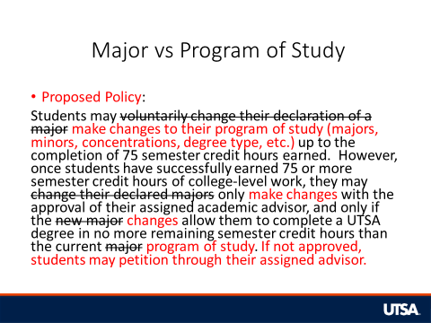
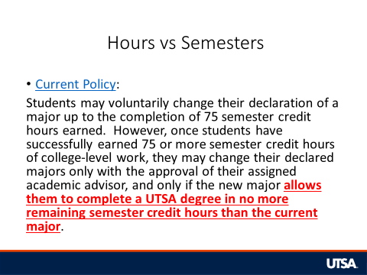

The second thing we need to address is whether credit hours needed or semesters remaining until graduation should be the deciding factor in these decisions. Currently, the policy mentions credit hours.

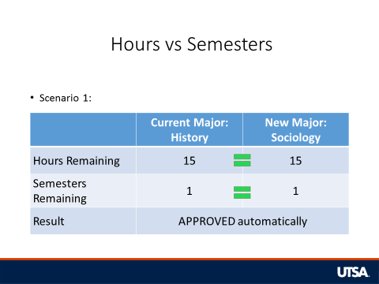
In this scenario, the current major and the new major have the same number of hours and same number of semesters remaining. Currently, the result would be automatic approval for a change of major.

Issues to consider:
- Should the courses required matter? One major may have a heavier workload remaining. The student may have already satisfied a senior seminar requirement in their current major but lack it and other UD coursework in the new major.
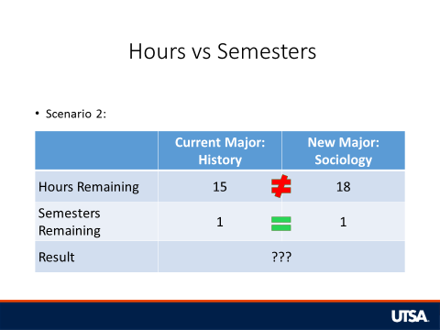

In this scenario, the new major requires slightly more hours than the current major, but the student could potentially graduate in the same number of semesters.
Issues to consider:
- The increased course load could be problematic for some students if they do not normally take a higher number of hours.
  - Would the decision change if the current major required 12 hours and the new major required 15 hours? Even though the new major would require more hours in the final semester, the student may be able to easily handle 15 hours.
- Should the courses required matter? One major may have a heavier workload remaining. The student may have already satisfied a senior seminar requirement in their current major but lack it and other UD coursework in the new major.
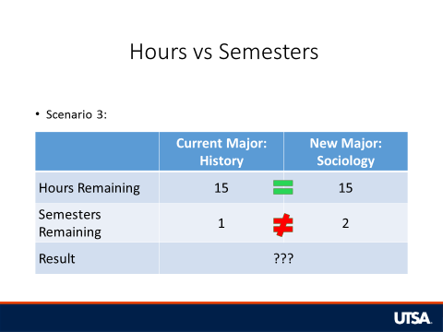
In this scenario, the new major requires the same number of hours as the current major, but it will require one additional semester due to course sequencing issues (prerequisites, availability, etc.).

Issues to consider:
- What if the student needs to be full-time each semester? Not only will the student have to take one additional semester, but they will end up taking at least 24 hours when they technically only need 15 to graduate.
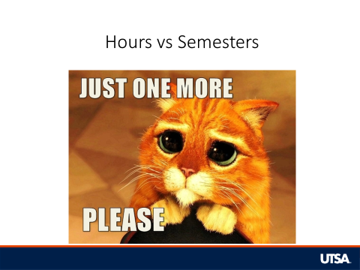
We all agreed that the number of semesters needed should be the ultimate deciding factor.
- Agree or Disagree? Any comments/concerns?
Some also favored allowing students to make changes if it would delay them by no more than one semester.
- Do we want to propose giving them this extra time?

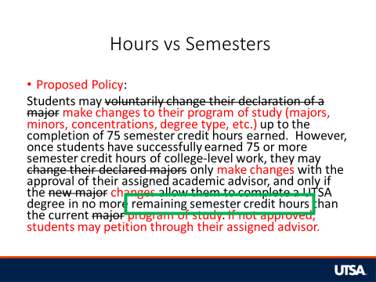
Will have to edit the wording depending on the decision.
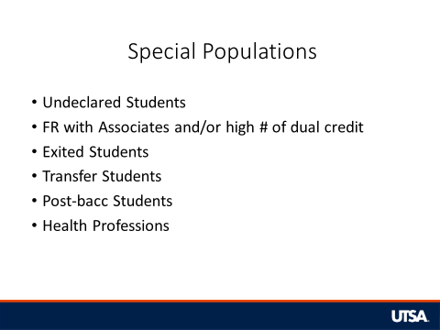

The third thing we need to address is that there are several special populations that we regularly see that will be affected by this rule, so we need to know how to proceed with them.
- Undeclared: The Provost wants students in a major by the 60 hour mark (Jan 2015 AAC meeting).
  - Recommendation: place a hold on these students at the 60 hour mark (or just keep the 45-hour hold on them).
  - Agree or Disagree? Any comments/concerns?
- Freshmen could potentially come in with a high number of dual credit hours or even an Associate’s degree (or more than one).
  - Hours earned before HS graduation do not count toward the 30/45 and other policies that penalize students for attempting too many hours.
  - Recommendation: Don’t include AP or dual credit hours in this policy.
  - Agree or Disagree? Any comments/concerns?
- Some students may be exited from a major after 75 hours and will have to change their major.
  - We might want to have some majors that they can change to automatically so that we don’t have to do a petition for them.
  - MDST isn’t always the fastest route for many.
  - Should the focus be more on what will help them graduate faster or what is more relevant to their goals?
  - Recommendation: These students should be able to automatically change to a major on a pre-approved list (likely those with higher free elective hours). They would have to petition to change to any other and cannot remain UND.
  - Agree or Disagree? Any comments/concerns?
- A lot of transfer students come in with close to or over 75 hours already.
  - Should these students be given a grace period? If so, how long?
  - They do not count in our graduation rates anyway, but they do have to worry more about the 30/45 policy (especially if they change).
  - Recommendation: These students should have 1 calendar year from admission term to change their major.
  - Agree or Disagree? Any comments/concerns?
- We assume that post-bacc students are essentially starting a new cycle, where their previous earned hours do not apply to this rule.
  - Recommendation: They have 75 “new” hours before having to stick with a major.
  - Agree or Disagree? Any comments/concerns?
- Students pursuing health professions may earn a higher number of hours before changing their minds or being denied admission to a program.
  - Should they be given special consideration?

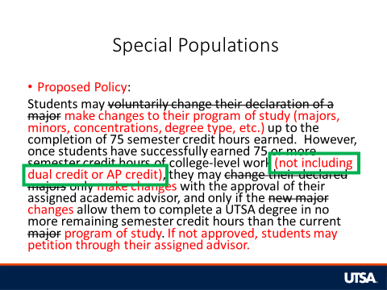
Add this based on the issue of AP/Dual Credit.

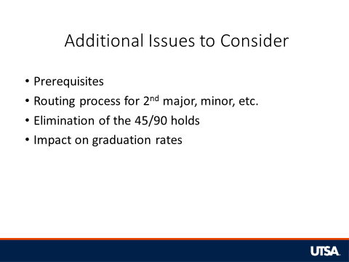
There are a few other issues that we want to clarify or that we still have questions about.
- When calculating the required number of hours/semesters needed, all prerequisites should be included.
  - For example, a Computer Science major might be required to take Precalculus (MAT 1093), even though it is not a major requirement, simply to be able to take Calculus I (MAT 1214) which is a major requirement.
- Petitions to change major would be sent to the Associate Dean in the college that houses the “new” major.
  - Where would we send the petitions for those wanting to add a second major, add a minor, etc.?
  - For instance, what do we do if a History major wants to add a Business Administration minor?
- If we eliminate the 45/90 holds, could that negatively impact our ability to inform students of this policy?
  - We could include a discussion about it in the 45-hour appointment as a preliminary warning.
  - Are people generally in favor of keeping or getting rid of these holds?
- We plan to ask the Associate Deans several questions related to the policy’s impact on graduation rates.
  - If a student doesn’t count toward our graduation rates (e.g. transfer student), would that influence the decision?
  - If a student has the potential to graduate in 4 or 6 years with one major but not the other, would that influence the decision?
    - What if they can’t graduate in 6 years in either the current or new major?

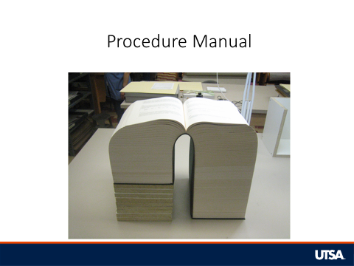

One of our long-term goals will be to create a centralized policies & procedures manual for advisors to make sure everyone is referencing the same materials if they have questions or when they are training new advisors, so once stuff like this is finalized, we will begin putting all of this information together for everyone.

