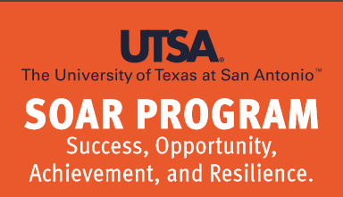
SOAR is a summer program committed to supporting and empowering freshmen on academic warning or probation to take an academic flight upwards towards academic success. The SOAR program is designed to get these students back on track academically.

What are the benefits of participating in SOAR?
- Students will create an academic success plan to clear academic warning or probation and receive assistance in identifying the factors that impacted their previous academic performance.
- Students will attempt to increase their GPA by enrolling in summer courses. Repeating and replacing courses will be highly recommended to students.
- Students will have the opportunity to receive information regarding academic resources.
- Students will receive support from faculty, staff and peer mentors.
- Students will attend workshops, events and activities encouraging them to take ownership of their academic future.

How do students sign up for participating in SOAR?
Students will be able to submit an interest card to their advisor or directly to the LEAD Student Success Office located in MS 1.02.04. Any direct referrals are also appreciated. LEAD staff will then complete all necessary follow-up with the student.

Is there any additional cost to participate in the SOAR program?
No, there is no additional charge to participate in this program. Students pay the standard cost of attending UTSA such as tuition, fees, housing, etc. Student may qualify for financial aid to help offset the costs.

Who can I contact for more information?
Contact Cynthia Rodriguez at 210-458-4595 or e-mail Cynthia.Rodriguez1@utsa.edu for additional information.


