SOC 4863: MIGRATION AND IMMIGRATION
MW 4:00-5:15 PM
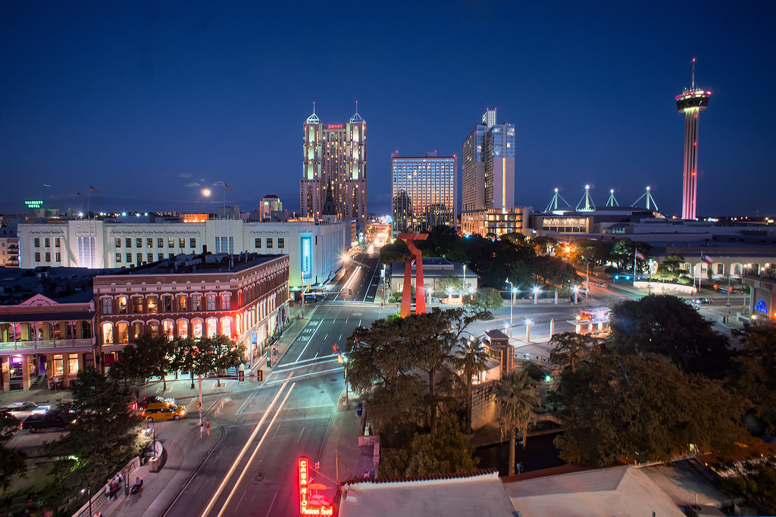

Are you interested in understanding why people choose or have no other choice but to migrate, especially across borders? Or why some folks may remain "immobile"? Want to better understand the current refugee “crises” in our border and around the world, and whether they are crisis (and of which kind)? Do you want more elements to assess whether climate change is going to create more displacement in the future (or already is doing so)? Would you like to also better understand the root causes of irregular/undocumented migration, and explore the ways in which immigration policy can better manage immigration and avoid irregular movement?
In this course, we will cover all of these issues, examining the theories that explain why people move and learning about important transnational migrations in history and today, including flows of refugees, asylum-seekers, and others displaced by political turmoil or violence, as well as by climate and other forms of environmental change. While the second half of the class has a stronger U.S. focus, examining historical and contemporary inflows from around the globe, we also briefly cover other very important migration systems, including (with varying degrees of depth) the European Union, Australia, or the Gulf Cooperation Council.

