With the removal of the free electives block, electives will need to be calculated using the 120 hour requirement and 39 upper division hour requirement within the degree block in DegreeWorks. You will need to count against how many hours are still needed for the core and major (and minor if they have one.)
It will be very important to stress to your students as you meet with them and review DegreeWorks that they need to pay attention to the degree block and all the requirements listed there, especially the 120 hour and 39 upper-division requirements.
Here’s our example:
We can see that the student needs 8 more hours to reach their 39 hours. They need 19 hours to reach their 120 hour minimum. Registered courses are taken in to account. It says “You currently have 101 hours completed or in progress.”
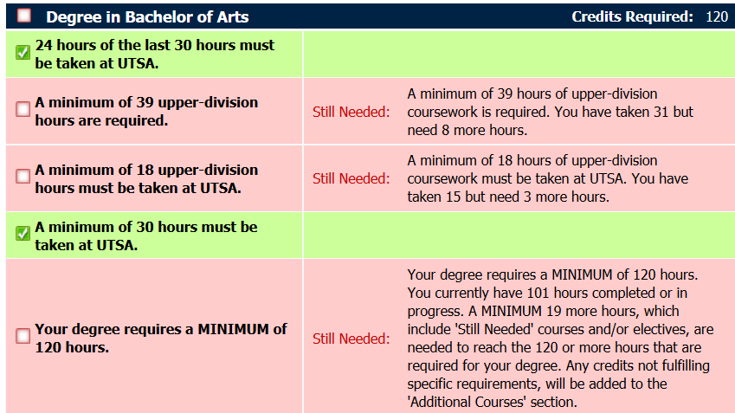
They need 3 more hours in the core.
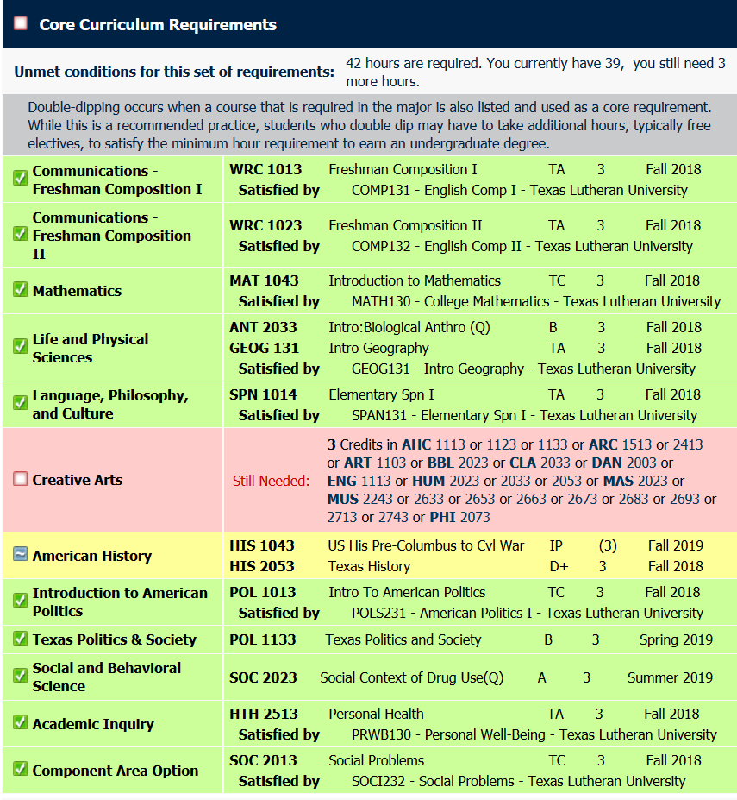
The major still needs 15 hours, 12 of which need to be upper-division.
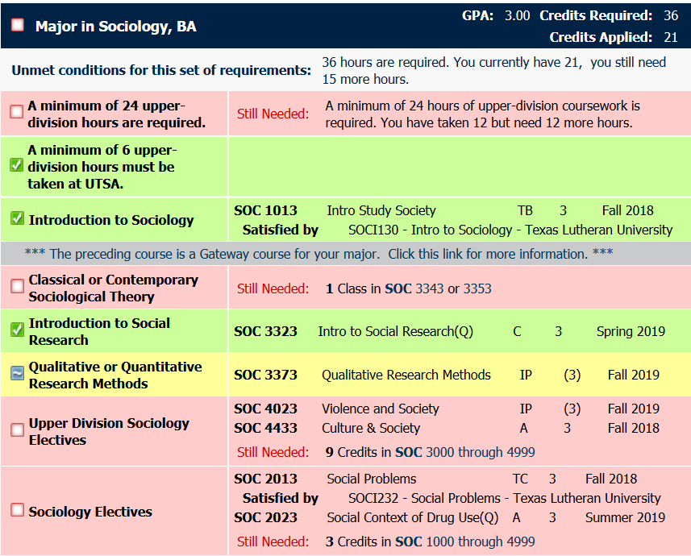
Total needed for core and major are 3 core + 15 in major = 18 hours needed. To reach 120 hours, the student needs 19 hours, which means they will need an extra hour of electives. Do any of them need to be upper-division though? No.
They will fulfill their still needed 8 hours of upper-division requirements to reach the 39 minimum as they fulfill their major requirements (since they still need 12 more hours of upper-division.)
There is no more need to make exceptions in a free elective block. Most exceptions that were made, were done in the free electives blocks since there were many adjustments that needed to be made depending on double-dips, if a student took major electives as upper-division or lower-division, etc. Changing the limit in the free electives blocks had to be made in multiple places, and that is no longer the case.

