AAC Thanksgiving  Potluck | 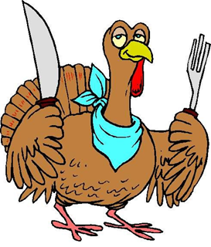

Come and enjoy the day with us! BB 4.02.10
Thursday, Nov. 17th, 2016 at 11:30am - 1:00pm
Main Entrée | Side Dish
1. Barbara: Turkey/Ham | 1. Sabina Kapoor
2. | 2. Sylvia M.: Salad
3. | 3. Jaylon Wilson
4. | 4. Kimberly P.: Kale Salad
5. | 5.
Appetizers | Drinks
1. Roxanna Nelson | 1. Brittany Gordon: drinks & cups
2. | 2.
3. | 3.
4.
Desserts
- Raquel Orozco
- Shannon Rios
- Yolanda Williams
- John Bonner

