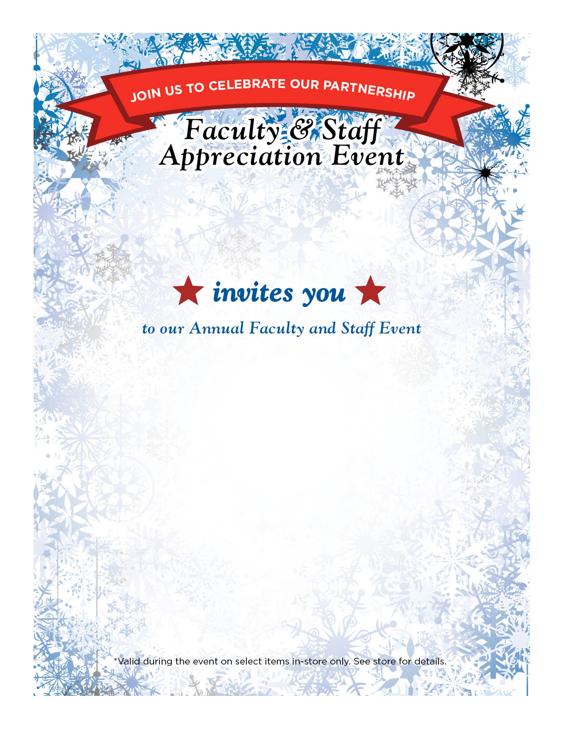
Rowdy campus Store

Thursday Dec 1st
Refreshments will be served at the
Main Campus and Downtown locations on
December 1st from 2:00 - 4:00 pm

Rowdy Campus Store – University Center
Rowdy Store Downtown - Frio Street Building

As a token of our appreciation,
we will be extending a 30% total
discount* on select merchandise

