Spring 2023
LTED 7863.001 Russian and Ukrainian
Contributions to Literary Theory,
Psychology, and Learning, Thursdays, 6:00 to 8:50 p.m.
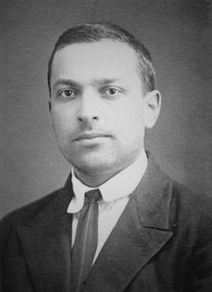
Taught by Professor Rosalind Horowitz, Interdisciplinary Learning and Teaching; and Educational Psychology, by way of Zoom

This course will focus on the contributions and life of Lev Vygotsky, a Russian psychologist, whose ideas have significantly influenced our views of reading and writing, cultural and social development of the child, and learning including special education. The Russian literary world and its scholars including Bakhtin-- advocating the “scientific method”, studying poetic language, social constructivism, and the role of languages in learning—are discussed. M.A. and Doctoral Students, Advanced Undergraduates, across all disciplines are welcome.

Lev Vygotsky (1896-1934)
Theory by Russian and Ukrainian scholars will be applied to real world contexts and problems students may experience in learning. Psychological tools--mediation, internalization, zone of proximal development-- and the purposes of play will be addressed. Distinguished Russian experts in the humanities will also be guest speakers to create an interdisciplinary perspective. Virtual tours of Russia.
Moscow Square
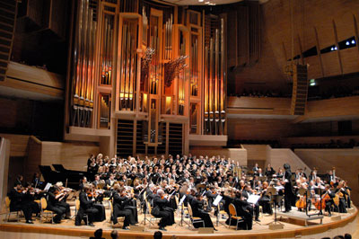
The professor was a visiting scholar to Russia and the Ukraine. Dr. Horowitz will also report on her visit and include your Zoom visit to the first Russian Museum of Art in St. Paul, MN, the only such museum in the US. This class may be used as an elective in a number of M.A. & Doctoral Programs – Reading and Literacy, Psychology, Bicultural-Bilingual Studies, Special Education, Educational Leadership and Policy, English, Classics, and the Russian Program. For further information, e-mail: Rosalind.Horowitz@utsa.edu. Moscow Symphony

