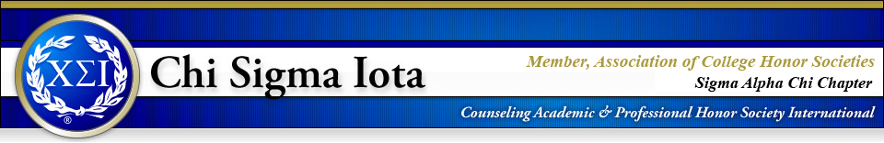

The Counseling Honor Society invites all counseling students to our January Workshop:

“Prevention of Campus Sexual Assault”
“Decrease your chances of becoming a victim or surprisingly accused
of an alcohol-related sexual assault through increased awareness
of the effects of alcohol on the brain

Dr. Marshall H. Smith, M.D.
Board Certified Forensic Psychiatrist and author of
“Sex While Intoxicated Crime or Not?”

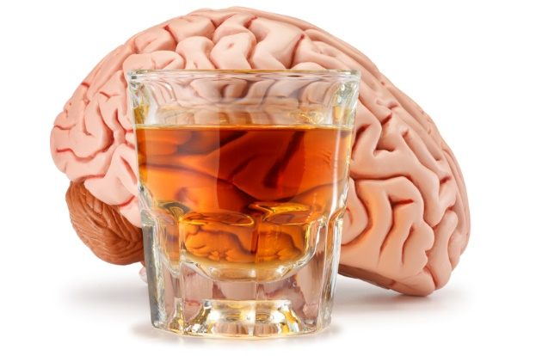

Saturday, January 27th
1:00 p.m. – 3:00 p.m.
Downtown Campus, Buena Vista Building, Room: BV1.328

The workshop will focus on the stages of alcohol intoxication, blackouts versus passing out, ability to consent after drinking, and life after being assaulted or convicted of having non-consensual sex.

Free to CSI Members
$5.00 for Non-members

