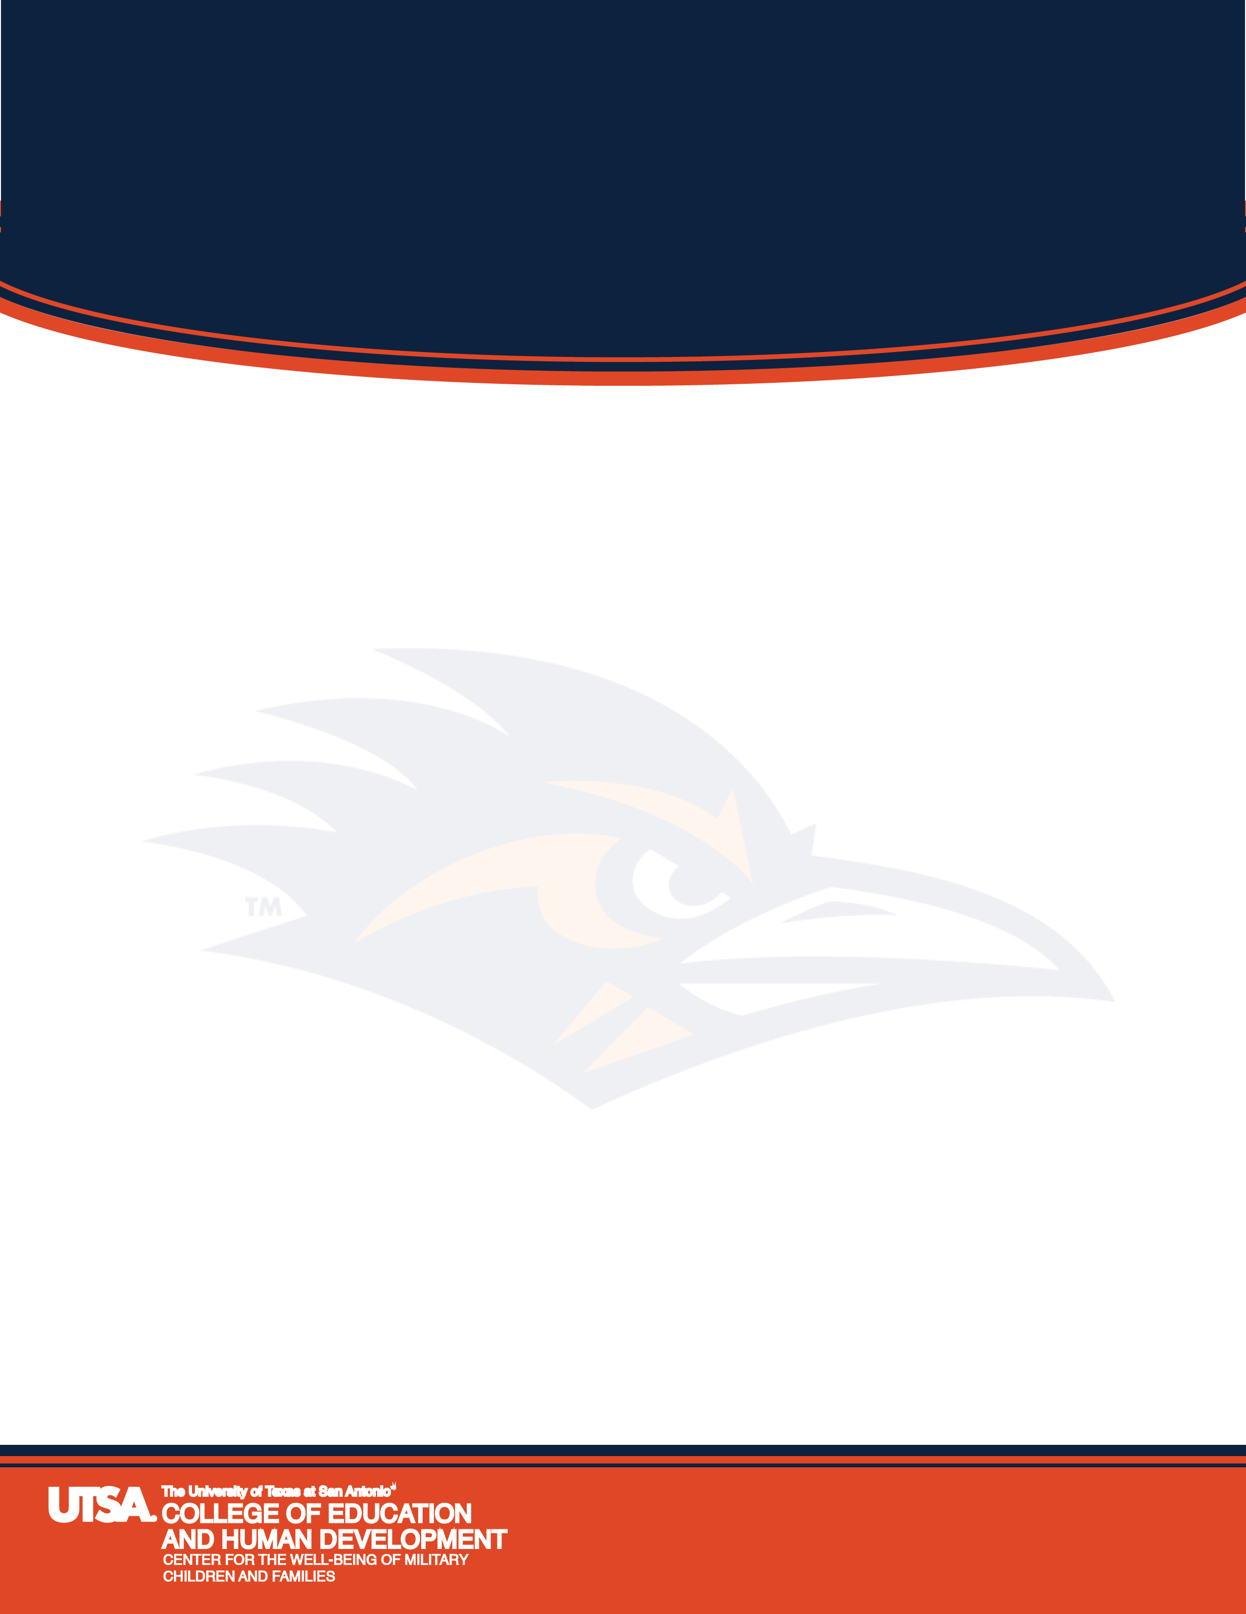
This training is provided by the Military Child Education Coalition (MCEC). It will provide insight to the many transitions that military children and families must make over the course of a military members career. The participant will receive useful resources and techniques for assisting families through these transitions. Current practices in resilience and the dynamics of the schools, the family and the military culture will be discussed.

*Chose only one day to attend this workshop as the two days are identical.

Friday, November 7, 2014*
UTSA Main Campus
One UTSA Circle
University Center/Harris Room
8:30 a.m. – 4:00 p.m.

Saturday, November 8, 2014*
Downtown Campus
501 W. Cesar E. Chavez Blvd
Buena Vista Bldg, BV1.338
8:30 a.m. – 4:00 p.m.
*Choose only one day to attend. The two days are identical in content.

For more information, contact Mercedes Zamudio at Mercedes.zamudio@utsa.edu or (210) 458-2608
Supporting Military Kids through School Transitions: Foundations

