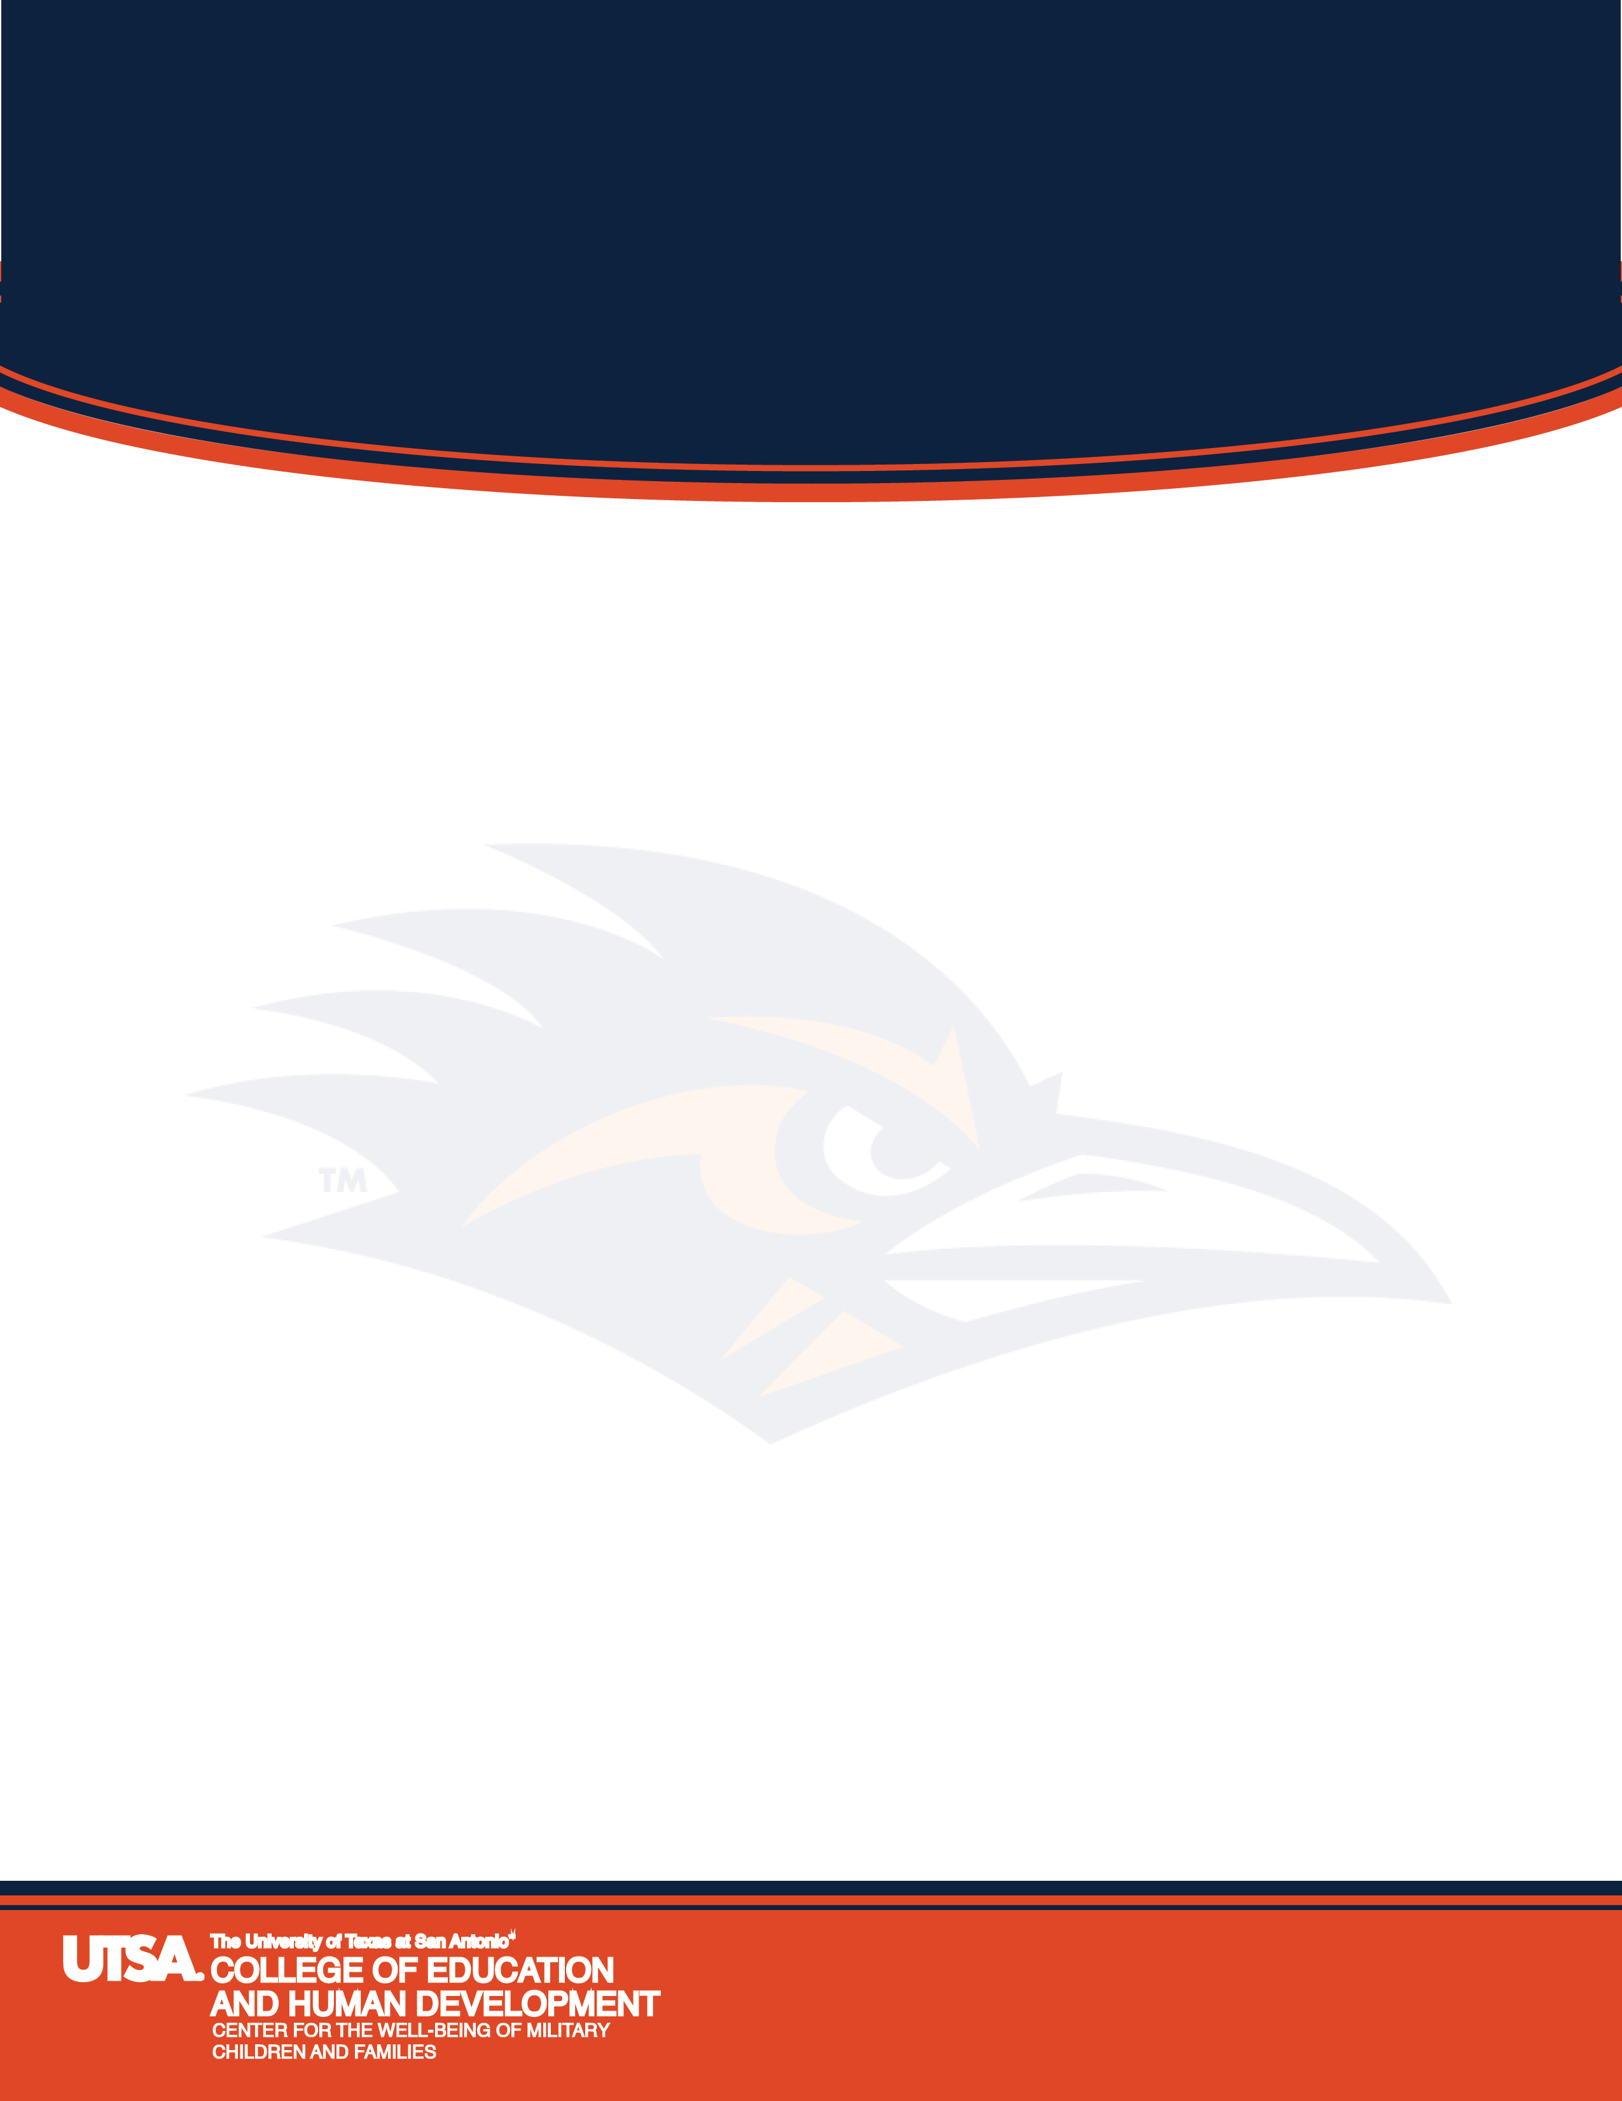
COEHD Faculty Workshop on Military Culture:

Preparing Our Students to Work Effectively with Military Connected Children & Families
In the Schools and the Community
For more information, contact Mercedes Zamudio at Mercedes.zamudio@utsa.edu or (210) 458-2608
An introduction to military culture with a briefing on the latest research and current status of military families. The session will feature experts who work with local school districts having large concentrations of military children and a panel including students and teachers from a military ISD as well as UTSA students and faculty who have worked with military children and families. The workshop is identical on the two dates; attend only one.
Friday, October 17, 2014
UTSA Main Campus
One UTSA Circle
Faculty Center Conference Room, 404.12C
1:00 – 3:15 p.m.

Monday, October 20, 2014
Downtown Campus
501 W. Cesar E. Chavez Blvd
Durango Bldg. DB 2.304
1:00 – 3:15 p.m.

