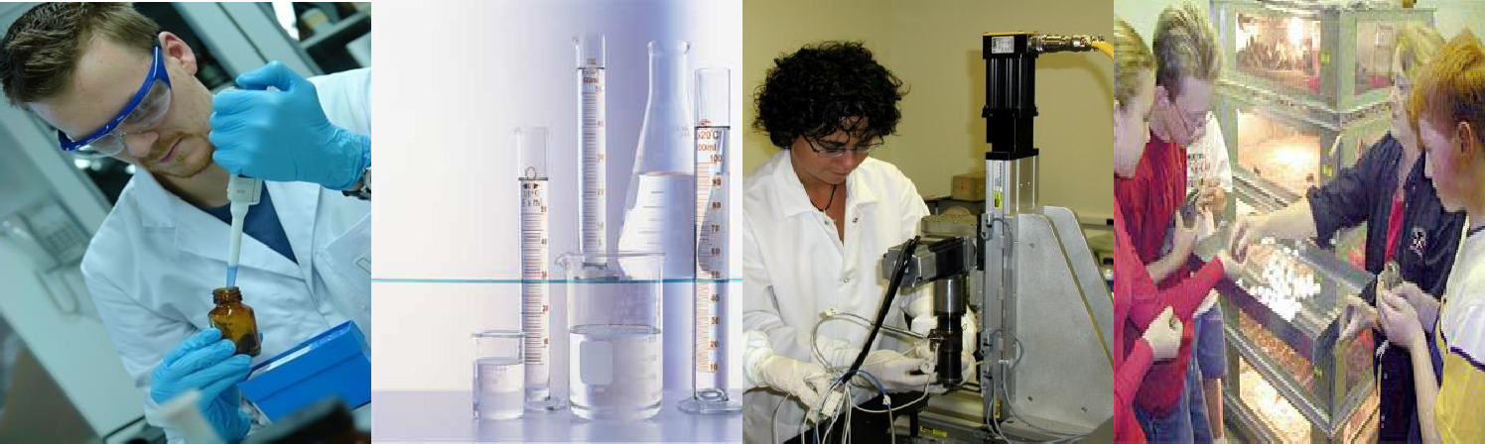The University of Texas at San Antonio

Center for Research & Training in the Sciences (CRTS)

Support of Competitive Research
SCORE Program presents
INFORMATIONAL TOWN HALL MEETING

1604Campus Monday, February 20th 10:00am – 11:00 am
Faculty Center JPL 4.04.12C

Contact Monica Carreon at 458-4976 for additional information on the SCORE program. http://www.utsa.edu/crts/score/

