

15TH ANNUAL COEHD RESEARCH COLLOQUIUM
Classic and Contemporary Educational Research at an Hispanic Serving Institution

THURSDAY MARCH 02, 2023
3:30 - 6:00 PM
H-E-B BALLROOMS 1604 CAMPUS

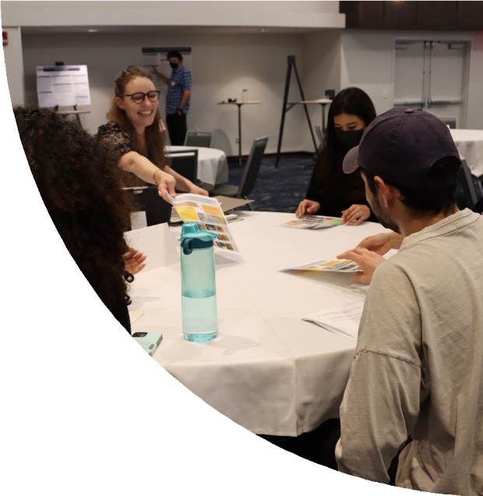

Accepting: Proposals for roundtables, posters, and demonstrations of research at any stage of development—from proposals for research to be conducted, on-going research, research that has been completed, research ready for publication.
100 words, with:
Title, author, institutional affiliation and department Purpose of the research
Summary of the research procedures-methods, quantitative or qualitative design
Findings acquired or expected
Implications for HSI’s and educational settings
Research Methods: Historical, Meta-Analysis, Neuroimaging, & Digital are welcomed

PROPOSALS ARE DUE SATURDAY, FEBRUARY 18TH, 2023 BY MIDNIGHT!
CONFIRMATION OF RECEIPT OF PROPOSAL TO BE FORWARDED TO FIRST AUTHOR.


QUESTIONS? CONTACT DR. ROSALIND HOROWITZ
Rosalind.Horowitz@utsa.edu

