ROTARY FOUNDATION GLOBAL SCHOLAR GRANT FOR GRADUATE STUDENTS
District 5840
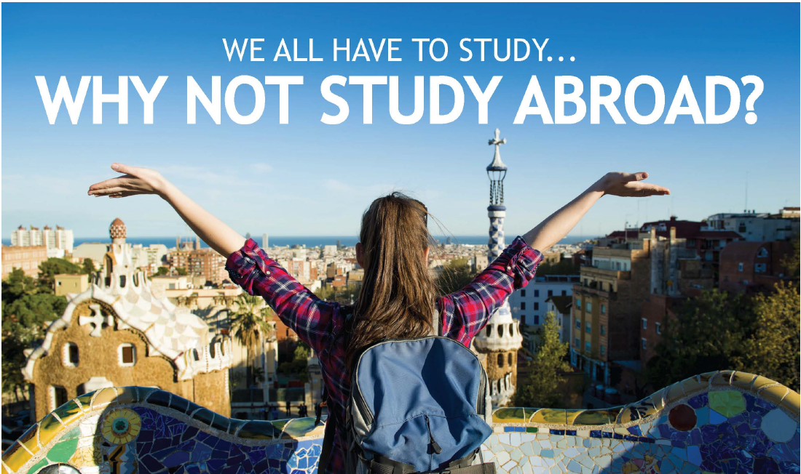
Grants starting at $30,000 and covering tuition, room & board, and various other study abroad expenses are available to Master’s degree candidates majoring in the following 6 areas (with preference given to candidates who have demonstrated an active past commitment in these areas as well):
- Peace & Conflict Prevention or Resolution

- Disease Prevention & Treatment
- Water & Sanitation
- Maternal & Child Health
- Basic Education & Literacy
- Economic & Community Development
Details and a complete application can be found at the following link:
http://www.rotary5840.org/SitePage/foundation-2017-18/global-grant-scholarships


Contact
Kelly Colotla
kcolotla@outlook.com/915-433-2247

Jane Burton
Jburton13@satx.rr.com/210-416-0852

APPLICATION DEADLINE FOR THE 2019-2020 SCHOOL YEAR IS NOV. 16, 2018

