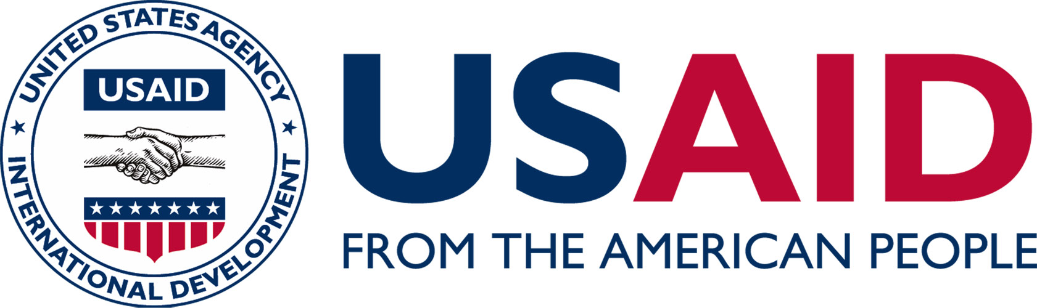

USAID Higher Education Webinar

Date & Time: Wednesday, May 28 | 10:00 a.m. - 11:30 a.m. (EST)
Registration Required: https://usaidhighered.eventbrite.com

USAID’s Global Development Lab and Bureau for Economic Growth, Education, and the Environment (E3) will host its first biannual webinar with higher education institutions on Wednesday, May 28, from 10:00 a.m. to 11:30 a.m. (EST).

The purpose of these webinars is three-fold: 1) to bring attention to USAID programs, policies and strategic investment areas that may be of interest to the Higher Education community; 2) to highlight the work of diverse higher education institutions on a range of development and global engagement fronts – with and without USAID funding; and 3) to share upcoming opportunities for engagement with USAID.

Webinar site: https://ac.usaid.gov/highered/

USAID Speakers:
Clara Cohen, Bureau for Food Security
Eric Johnson, Bureau for Economic Growth, Education, and Environment
Ticora Jones, U.S. Global Development Lab

Higher Education Institution Speakers:
Joan Smith, Red Rocks Community College – Clean Energy Partnership in Jordan
David Trichler, The College of William and Mary – AidData Center for Development Policy
Andrew Baird, RTI and university partners in Liberia and Philippines

