**Combination Editing**

Combination Editing (“Combo Edits”) in UTShare PeopleSoft will go into effect for UTSA on Monday, January 25.

**What are Combo Edits and how will they affect you?**

A Combo Edit is an UTShare system rule that is put into place to do one of two things: (1) require specific information on a transaction (i.e., require a function code on an expense); or (2) disallow certain information (i.e., disallow use of an account number when using a certain fund).

**What UTShare transactions will be affected by Combo Edits?**

This change affects **all** modules; therefore, if you get an error that references a combo edit rule, our PeopleSoft configuration requires that you fix the error before the transaction can be saved.

**How do I know if I have a Combo Edit error? What will it look like?**

Here is an example of an error message that you may get on a combo edit message for an AP voucher. The error message will appear differently depending on the module, but the rule will always be referenced:

**There are two errors on this AP transaction that will create a Combo Edit error message:**

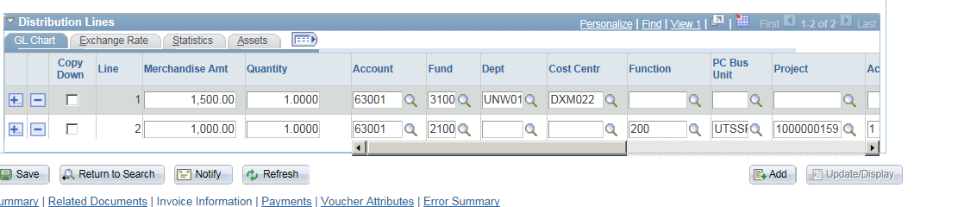

**_________________________________________________________________________________________________________________________**

**This is an example of the error message on Line 1 and the instructions:**

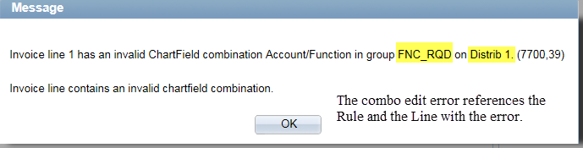

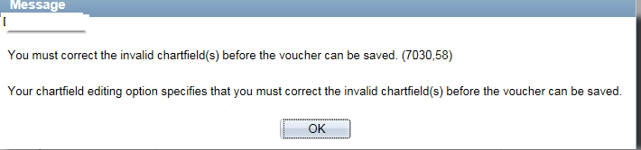

**Once you correct the initial error and save, if there are any additional Combo Edit errors, they will display one at a time:**

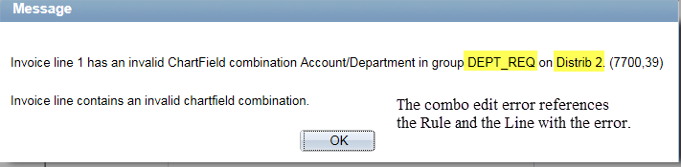



**You will know when all combo edit errors have been corrected because you will then be able to “Save” the transaction.**

**What are the specific Combo Edit rules? How will I know what to fix?**

Each Combo Edit error will reference a specific rule. The rules are listed below. An example of an error is included in the screenshot above.

|  |  |  |
| --- | --- | --- |
| *Rule* | *What Causes this Error* | *How To Fix* |
| ACC_FUND_V | There are two possible causes:  A) A depreciation account has been used with an incorrect fund.  B) This relates to specific balance sheet receivable accounts. These receivable accounts are tied to specific sponsored program fund groups. | 1. Departments should never use depreciation accounts; to correct, please enter a different account number. 2. Departments should never use accounts receivable accounts; to correct, please enter a different account number. |
| AFFIL_RQD | Specific accounts (Due To/From Components and ComponentTransfers) require the use of an Affiliate code within the chartfield. | Departments should never use an account that requires an affiliate; to correct, please enter a different account number. |
| CAP_INT | Capitalized interest can be only used with specific funds. | Department should never use a capitalized interest account; to correct, please enter a different account number. |
| DEPT_REQ | A department is always required on revenue and expense transactions. | The department is missing. Please use a speedtype wherever possible to avoid this error. If a speedtype can’t be used for the particular transaction, please add the department. |
| FNDAFF_ACT | Specific accounts (Due To/From Other Funds and Intrafund Transfers) require the use of a Fund Affiliate code within the chartfield. | Departments should never use an account that requires a fund affiliate; please enter a different account number. |
| FNC_RQD | A Function (or NACUBO Code) is required on all revenues or expenses. | The function is missing. Please use a speedtype wherever possible to avoid this error. If a speedtype can’t be used for the particular transaction, please add the function. |
| FND_RQD | A Fund is required on all transactions. | The fund number is missing. Please use a speedtype wherever possible to avoid this error. If a speedtype can’t be used for the particular transaction, please add the department. |
| FUND_AFFIL | A specific fund affiliate code is required on all transactions using account 71330. | Departments should never use account 71330; to correct, please enter a different account number. |
| FUN_9910 | Fund 9910 only allows use of balance sheet accounts. | Departments should never use fund 9910. Please use a speedtype or correct the fund number. |
| GIFTS_OPER | Account 45100 (gifts for operations) is only valid on funds 5500 and 5600. | Either the cost center or the account needs to be changed. Gifts can only be reported in Gift or Endowment funds. |
| GMUNALLOW | Grant projects cannot use accounts 67102, 67717 or 67718. | Departments cannot charge Social Club Dues or Late Payment Interest to a Grant Project; to correct, please enter a different account number. |
| INV_SAL_WG | Salary, wage, and benefit accounts are not valid on the following funds: Unexpended Plant, Investment in Plant and Loan Funds. | Department should never use salary, wage or benefit accounts on transactions. However, when setting up appointments or processing hiring changes, make sure there are no appointments to these fund groups. |
| PCARD | The PCard default account must be changed. | Account 67660 is the default for all PCard transactions. That account is invalid and must be changed to the proper account for the expenditure. |
| PROJ_FUNCT | Grant Projects are only valid with specific functions (NACUBO Code). | If you get this error – you are using a grant project and you need to change the function. If you use your speedtype, you can avoid this error. Please use a speedtype or correct the fund number. |
| RSFUN_PROJ | Funds 5100, 5200, 5300, and 5400 are only valid with a grant project ID. | If you get this error, you are either (1) using the incorrect fund with a grant project ID and should correct the fund; or (2) you are using this fund but are not using a grant project – correct to a cost center or change to a grant project. Please use a speedtype wherever possible to avoid this error. |
| SADONLYACT | These accounts are only to be used by UT System. | Departments should never use one of these accounts; please enter a different account number. |
| SP_PRG_REV | Sponsored Program Revenue – Fed, State, Local or Private and Sponsored Program IDC are only valid with specific combinations. | Sponsored Program Revenue is only valid for grant projects and specific funds. Sponsored Program Indirect Cost Revenue is only valid for fund 3100. If you receive this error, the account and project needs to be reviewed and a correction made either to the account, fund or project ID. |
| STATE_APRO | Balance in State Appropriation accounts and State Appropriation revenue is only valid on funds 2100 – 2200. | Departments should not use State Appropriation balance sheet or revenue accounts; please enter a different account number. |
| STUDNT_REC | There are two possible causes:  A) A student receivable balance sheet account has been used. These accounts are only valid for E&G, Designated, Auxiliary and Agency funds.  B) A tuition and fee revenue account has been used. Tuition and fee accounts are only valid for E&G, Designated and Auxiliary Funds. | 1. Departments should not use student receivable balance sheet accounts; please enter a different account number. 2. Check the account you are using to make sure it is correct. These accounts should only be used for tuition and fees which are normally paid through Banner. |

**Further Questions?**

If you have any questions about combination edits after reading the materials, please email [Accounting.Office@utsa.edu](mailto:Accounting.Office@utsa.edu).