Award Close-out – Interim Process
This interim process's purpose is to provide guidance on the award close-out process and responsibilities between the College Research Administrators and the Grants & Contracts Financial Services Office while an SOP is being generated.

Team Responsibilities:
Research Administrators:
- Initiate Award Closeout
- Confirm final expenditures with PI as final
- Confirm all cost share obligations have been met
- Confirm all reconciliations are completed
- Confirm all personnel funding is updated off the award
- Confirm with PI all non-financial milestones have been sent
- Provide fixed price residual cost center for PIs
- Fill out Award Close Out Form
- Document if there is cost share on award
Grant Accountants (GCFS):
- Complete financial award closeout

Process:

- PI and PAA receive an email from Research IT notifying them about an award expiring soon.

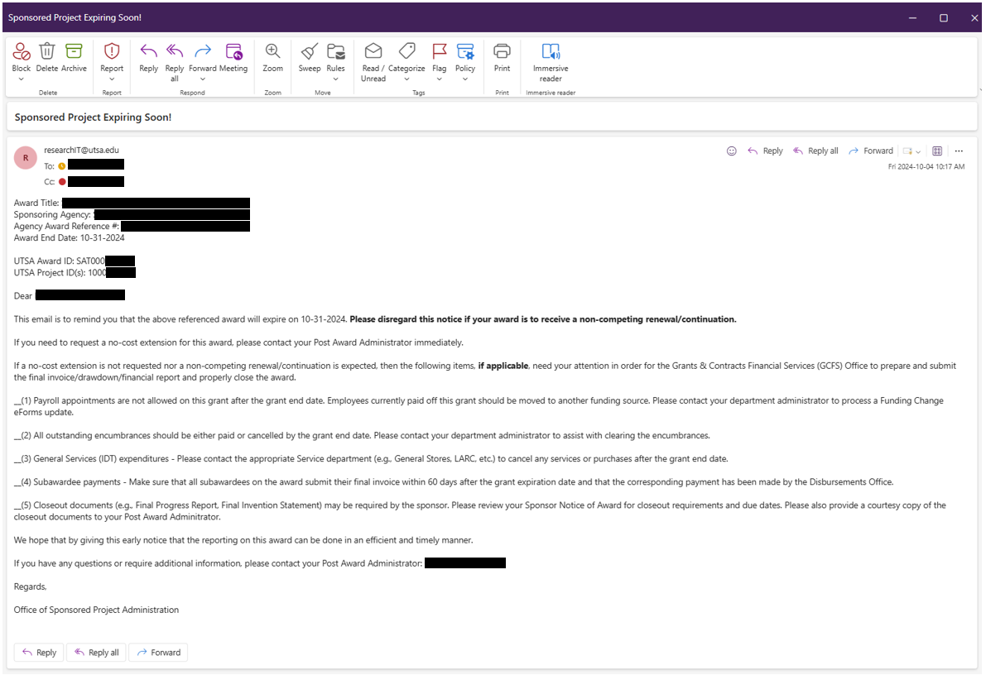

- RA verifies with PI and BSC the following:
With PI:
- All Expenses (including subaward expenses) on the Award are accurate and final. Provide Summary and detailed financial report for PI review.
- Confirm all cost share obligations have been met
- All deliverables have been completed and accepted by the Sponsor – This includes, but is not limited to: Programmatic Deliverables, and Final Progress Reports.

With BSC:
- Confirm SAHARA reconciliations are completed
- Personnel fund source has been updated.

- RA completes the Award Close-out form and emails GCFS requesting the closeout. Please attach PI and BSC confirmations of items listed in #1.
Subject Line: Award Closeout Request: PI [PI Name]; Award [SAT000XXX]
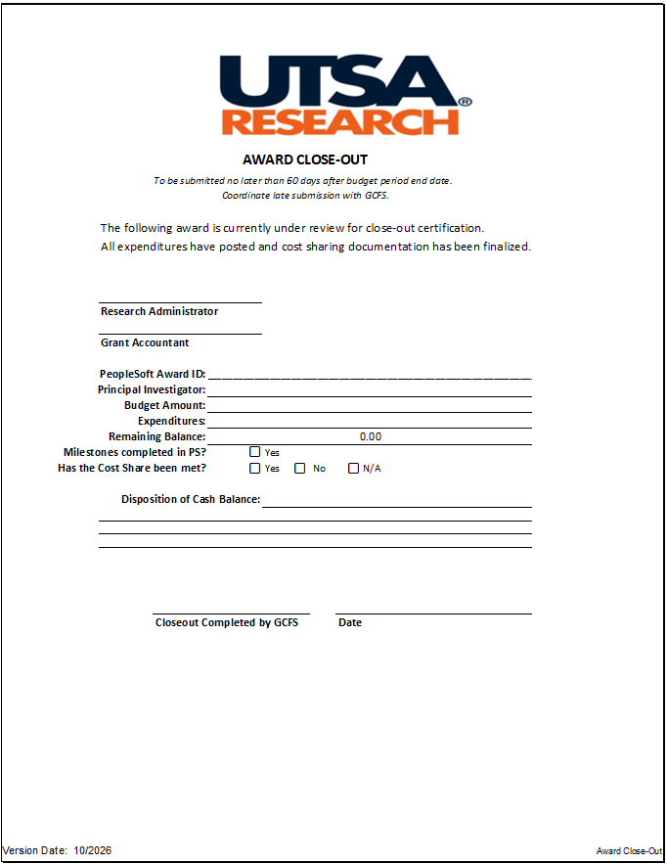

- GCFS process award closeout.
For fixed price awards residual balances refer to: https://www.utsa.edu/hop/chapter10/10.14.html

