Award Close-out – Interim Process
This interim process's purpose is to provide guidance on the award close-out process and responsibilities between the College Research Administrators and the Office of Sponsored Projects while an SOP is being generated.

Team Responsibilities:
Research Administrators:
- Initiate Award Closeout
- Confirm final expenditures with PI as final
- Confirm all cost share obligations have been met
- Confirm all reconciliations are completed
- Confirm all personnel funding is updated off the award
- Confirm with PI all non-financial milestones have been sent
- Provide fixed price residual cost center for PIs
- Submit closeout request to OSP
Grant & Contract Administrators (OSP):
- Fill out Award Close Out Form
- Confirm all non-financial milestones are completed in PeopleSoft
- Document if there is cost share on award
Grant Accountants (GCFS):
- Complete financial award closeout

Process:

- PI and PAA receive an email from Research IT notifying them about an award expiring soon.

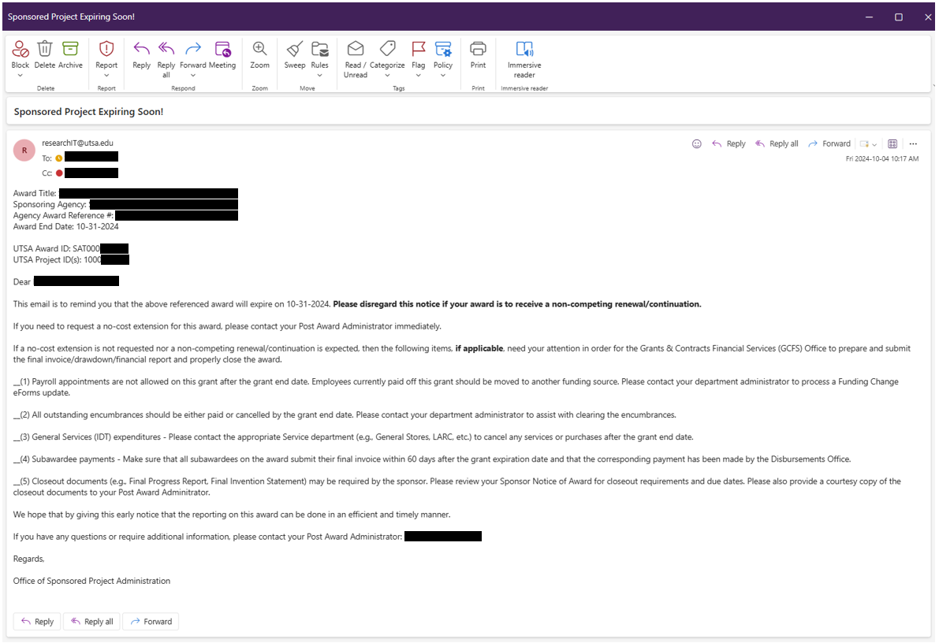

- RA verifies with PI and BSC the following:
With PI:
- All Expenses (including subaward expenses) on the Award are accurate and final. Provide Summary and detailed financial report for PI review.
- Confirm all cost share obligations have been met
- All deliverables have been completed and accepted by the Sponsor – This includes, but is not limited to: Programmatic Deliverables, and Final Progress Reports.

With BSC:
- Confirm SAHARA reconciliations are completed
- Personnel fund source has been updated.

- RA sends an email confirming the above items to OSP and include any cost center(s) to be used for any fixed price residuals. Please attach PI and BSC confirmations of items listed in #1.
Subject Line: Award Closeout Request: PI [PI Name]; Award [SAT000XXX]
- GCA completes the Award Close-out form and emails GCFS requesting the closeout.
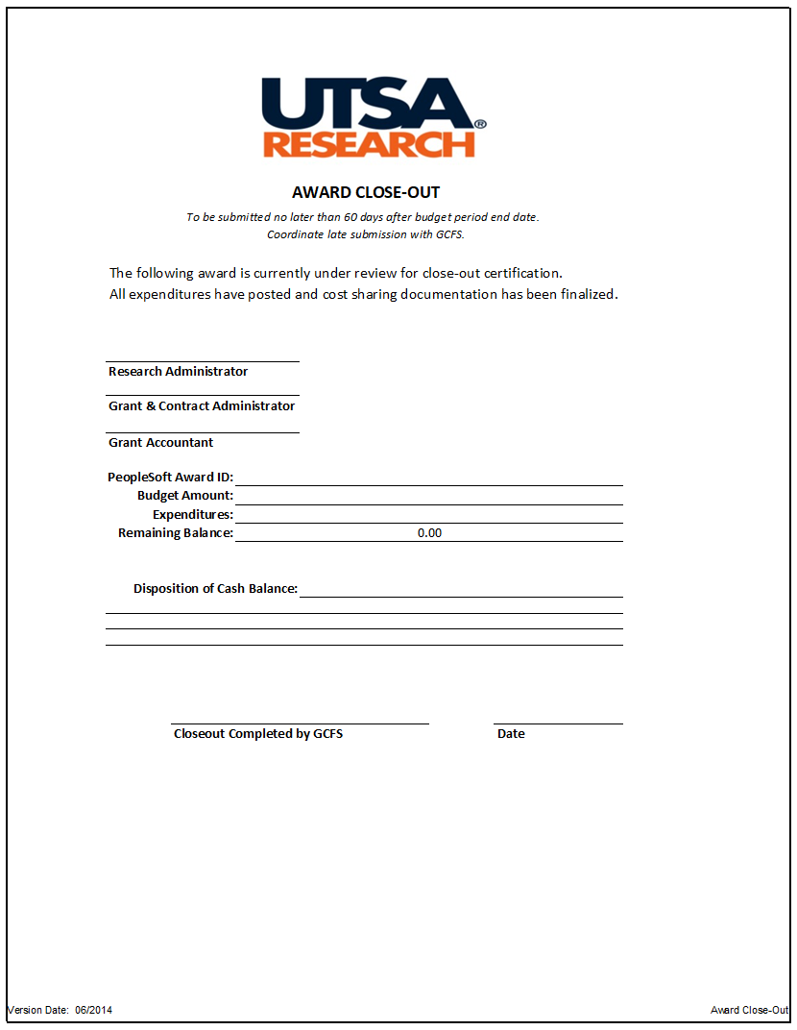

- GCFS process award closeout
For fixed price awards residual balances refer to: https://www.utsa.edu/hop/chapter10/10.14.html

